CURRICULUM VITAE

GAUTAM SINGH

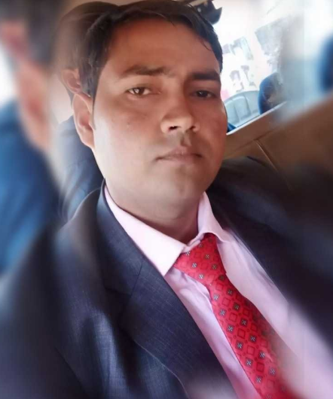

House No – 458, Gali No.2,

Garg colony Ballabgarh Fbd (HR) 121001

Mob – 9953742253,9760384480

Email- gautamluck143@gmail.com

Career Objective

To work in the most challenging position with an organization that provides ample opportunities to learn and contribute my bit for the success of organization**.**

A Brief Overview

* Diploma in Mech. Engg. + B.Tech in Mech. Engg. 8+ years of experience in Quality Management System.
* Presently working as a Asst. Manager Q.A experience in Quality Management Systems, **IATF 16949:2016, OHSAS 45001, ISO 14001**
* Knowledge of core tools - **PPAP, FMEA, APQP, MSA, SPC, 7 QC Tools, Calibration**
* **Knowledge of Processes – Turning, Milling, Grinding, ID Broaching, Threading, Tapping, Gear Hobbing, Gear Shaving, Gear Shaping, Cold forging, Hot Forging, Auto parts**
* Handle Audits ( **Internal & External Audits, Vendor site, 3rd party Audits** )
* Certified internal auditor of  **OHSAS 45001, ISO 14001,**
* Played key role in successfully **establishment of Machining plant after shifting from one location to another location**
* Successfully **establishment of Forging Plant**

OFES

Professional Background

SIONAL QUALIFICATION

Total Working Experience - 9 Years

Current Experience :

**Vishwakarma Auto Parts PVT. LTD. Sr.Engg. QA (Quality System) Nov.-2018 - TILL TODAY**

**Company Profile -**

**VAPPL** is leading manufacturer of Precision Turned And Machined Steering and Suspension Components and is a part of Vishwakarma Group. VAPL foundry is one of the finest foundry with world class technology for producing Grey Cast Iron and Ductile Iron Machined Castings. Today, the group is serving the auto parts industries with three plants having TS 16949 & ISO 14001 certifications.  
The company is fully equipped with world class testing facilities for Steering and Suspension parts.

Major Customers are CNH, Ashok Leyland, TAFE, Escorts, JCB, Bridgestone, VST, Federal Mogul, ZF, Glo Grid etc.

Key Deliverables :

* **MANAGEMENT REPRESENTATIVE ( IATF 16949 : 2016 )**
* Responsible for Plan, develop, implement and maintain quality systems & procedures conforming to: IATF 16949:2016
* To conduct Internal Audit
* To face Customer Audit & Certifying agencies Audits and submission of evidences for closure

of non-conformances

* **QUALITY ASSURANCE & CONTROL**
* Customer Complaint Handling and analysis, follow-ups and corrective actions
* Attaining customer satisfaction through prompt Counter Measures in 8 D format, 5W Rule Sheet by using effective Problem solving tools and techniques
* Problem Solutions with thorough Analysis using Structured Quality Tools like Pareto Analysis, Quality Defect Matrix , Q-Components and Zero Defect Line concept
* To conduct the Product Audit , Process Audit & System Audit as per plan
* Analysis of daily In-house rejection and to find out the Root Cause of the problem to reduce In-house rejection by using quality tools
* Responsible for Calibration, MSA, SPC and Improvement in Measurement System and Process
* Active member of APQP CFT.
* Responsible for preparation and updation of PPAP Documentation.

|  |
| --- |
| * **SUPPLIER QUALITY ASSURANCE** * Strategic Analysis for Worst case suppliers and Improvement / Up-gradation actions * Process and product and system audit at Suppliers End and Action Plan to clear the Non-Conformities in addition of perpetual audits * Review and directions for Defect free supplies from associated suppliers through regular Monitoring and Audits   Past Experience : |
|  |

**Choyal Industries (P) Ltd Faridabad SR. Engineer Q.A. March-2016 -Oct-2018**

M/s Choyal Industries ISO 9001:2008. Ir is Manufacturer of wide range of CNC Turned parts for **Railway Parts**,Tractor parts,Auto parts, Complete chain pulling, air brake system parts, steering knuckle,coupler parts, bmbs (boggie mounting brake system), socker parts etc.

Major Customers are Escorts (RED),Windsor, Ace, Honda,JCB etc.

**NBG Printographic m/c co. (P) Ltd Engineer– Q.A Oct.-2014 - Feb-2016**

NBG Printographic Machinery Co. Pvt Ltd All types of printing machinery and Auto parts check in standard room (CMM) and Assy Incharge.

Major customers are : Meritor, Daimler, Graziano, Axle Tech, Ognibene etc.

**HI-TECH GEARS LTD. Engineer – Q.A - Feb.2014-Sep.2014**

HI-TECH GEARS LTD.(An ISO/TS16949& ISO 14001& OHASAS-18001, TPM Consistency award winner, Singo Certified Company ) is engaged in **manufacturing of Spur Gears, Helical Gears and Timing Gears, Flange etc.** Major Customers are Hero Honda, Honda, Honda Siel Power Products, Honda Siel Cars, Hindustan Motors, New Holland , Robert Bosch (Germany), Yamaha, Getrag (Sweden)

**N.K.Micro Pvt Ltd Asst. Quality ENGINEER - Feb.-2012-Dec-2013**

N.K. Micro We are an ISO9000 certified company we are EM suppliers for machined turned parts specially gear blanks. We are equipped with cnc machining and turning centers aparts from a back up of conventional mchines. At the moment N.K.Micro production is based on the following sectors: automobiles, industrial and military vehicles, ground motions machines, tractors, railways and robotics. Major customers are : Honda,Maruti, JCB,Ace,Escorts, Ashok Leyland, ZF, CNH, DANA etc.

Strength

* Influencing & Analytical skills
* I am honest & quick learner. If I take any work in my hand then I fully concentrate that work. I'm a quick learner also I have the ability to learn quickly anything
* Good Leadership, Ability to handle manpower
* Positive Attitude, Self Motivated & Self Driven

Weekness

* I can't say easily no to anyone
* Little bit emotional sometimes so easily believe the person

I am trying to recover my weakness in a good manner

Personal Details

Name : Gautam Singh

Father’s Name : Shri Mahesh Chandra

Language Known : Hindi, English.

Date of Birth : 01/01/1991

Marital Status : Married

Sex : Male

Nationality : Indian

( ***GAUTAM SINGH***  )